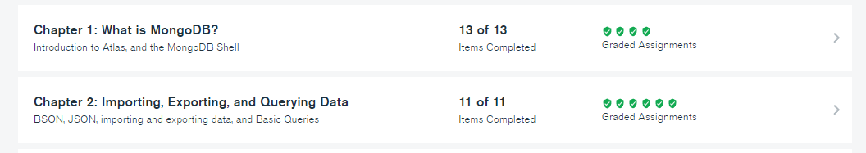

mongodump --uri "mongodb+srv://<your username>:<your password>@<your cluster>.mongodb.net/sample_supplies"

mongoexport --uri="mongodb+srv://<your username>:<your password>@<your cluster>.mongodb.net/sample_supplies" --collection=sales --out=sales.json

mongorestore --uri "mongodb+srv://<your username>:<your password>@<your cluster>.mongodb.net/sample_supplies" --drop dump

mongoimport --uri="mongodb+srv://<your username>:<your password>@<your cluster>.mongodb.net/sample_supplies" --drop sales.json